Iris data set

Specie ‘setosa’

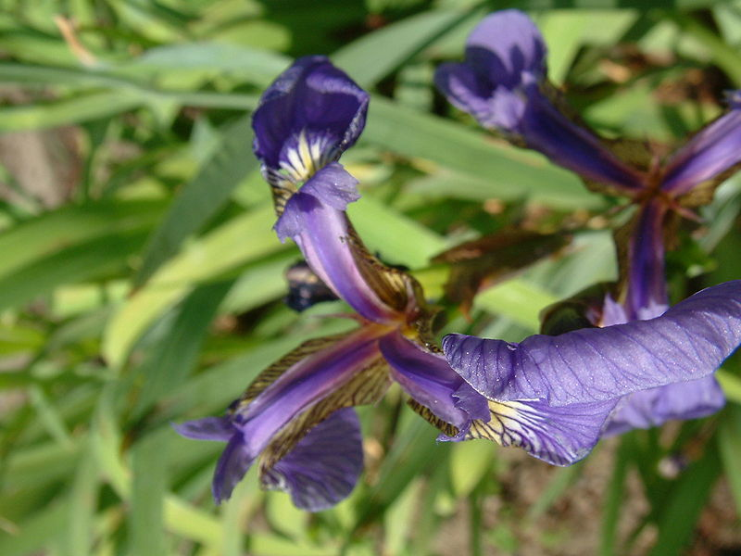

Specie ‘versicolor’

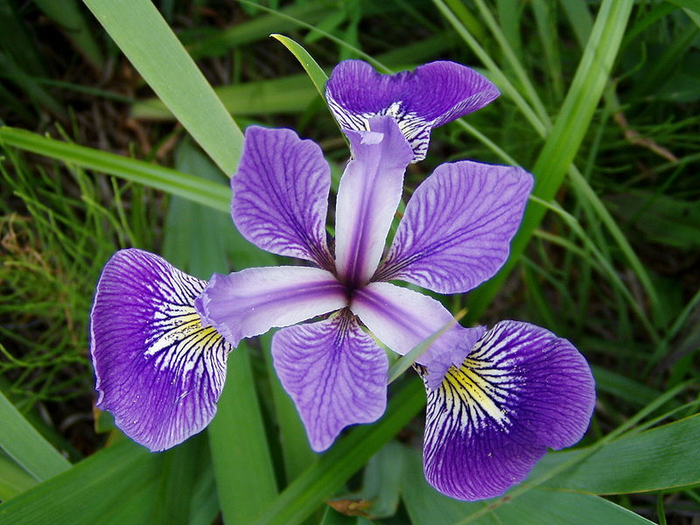

Specie ‘virginica’

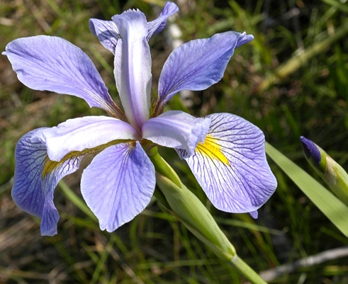

load fisheriris

% meas 150x4 double
% species 150x1 cell

%the 4 columns contain information on:
%Sepal length in cm SL
%Sepal width in cm SW
%Petal length in cm PL
%Petal width in cm PW

